chemistry IA Proposal form
Student Name: 姚苏倪 | Student Number: 2022512 |  | chemistry Level: HL
Level:(Please tick) ( )SL ( ✔ )HL
What is your IA research question?
(Please state the independent and dependent variables clearly. The project shows your originality which is not based closely on a common lab done in class)
What is the optimum boiling time of spinach to reduce the oxalic acid while reserving vc content?
Why do you choose this topic?
(Please give evidence with significant independent thinking, initiative, interest, creativity, or curiosity.)
Spinach is a common vegetable we eat in our life. While it contains nutrition such as vitamin B12, B22 and C, it also includes oxalic acid. Oxalate can combine with other minerals in the body to form compounds such as calcium oxalate and iron oxalate. Some individuals with high oxalate levels may develop kidney stones. Scientific experiment shows that boiling spinach can reduce the amount of oxalic acid in spinach. However, as the boiling time increase, a large amount vitamin C also dissolve in water in a high temperature environment. In this assignment, I hope to investigate the concentration of oxalic acid and vitamin C in spinach with varying boiling time, and thus derive an optimal boiling time of spinach such that the oxalic acid is mostly lost while reserving vitamin C content.
What type of investigation do you choose? (please tick)
( ✔ )hands-on practical
( )data-base
( )simulation or modelling
( )others, please indicate: _________________________________
What is the background info for your research? What hypothesis can be made that relates to the research question?
(you can present all of the appropriate chemical theory that is relevant to the investigation)
Spinach is a common vegetable we eat in our life. While it contains nutrition such as vitamin B12, B22 and C, it also includes oxalic acid. Oxalate can combine with other minerals in the body to form compounds such as calcium oxalate and iron oxalate. Some individuals with high oxalate levels may develop kidney stones. Scientific experiment shows that boiling spinach can reduce the amount of oxalic acid in spinach. However, as the boiling time increase, a large amount vitamin C also dissolve in water in a high temperature environment. In this assignment, I hope to investigate the concentration of oxalic acid and vitamin C in spinach with varying boiling time, and thus derive an optimal boiling time of spinach such that the oxalic acid is mostly lost while reserving vitamin C content.
To measure the oxalic acid content, the following reaction is considered:
3 H2C2O4 + K2Cr2O7 + 4 H2SO4 → Cr2(SO4)3 + K2SO4 + 6 CO2 + 7 H2O
And to measure the vc content, iodine test is used:
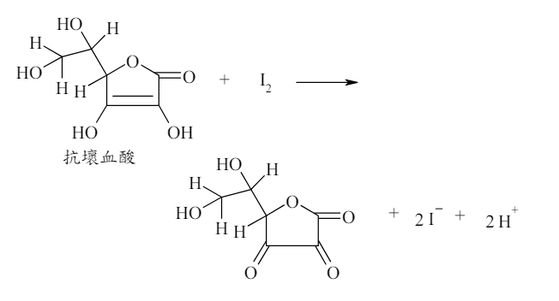
Hypothesis:
The concentrations of oxalic acid/VC in each spinach are the same.
Different parts of spinach have the same concentration of oxalic acid/VC.
How to control variables?
(Please fill in the following blanks regarding variables)

Identifying variables |  | Methods to control variables
Independent variables | Boiling time of spinach 0s (fresh spinach), 10s, 20s, 30s, 40s, 50s, 60s, 70s, 80s | When spinach is put into the beaker, start the stopwatch and when the time is reached, put the spinach out.
Dependent variables | Concentration of oxalic acid and vitamin C
Controlled variables | Temperature of water | Bath the test tube into 298K water in order to control the temperature by absorbing the heat produce by the decomposition.
Controlled variables | pressure | Do the experiment at 1 atm, keep the delivering tube uncongested.
Controlled variables | Volume of water | The water should be 300ml in 298K temperature and 1 atm pressure

What apparatus/materials are needed?
Materials:
K2Cr2O7
Distilled water
Dilute H2SO4
NaI
KIO3
HCl
Starch
Apparatus:
Analytical balance (0.0001 g)
alkaline buret (25 mL)
acid buret (25 mL)
pipette (25 mL)
volumetric flasks (100 mL and 1,000 mL)
conical flasks (250 mL)
beakers
glass rods
alcohol lamps
thermometer
wire racks
funnels
filter paper
juicer (brought from home)
What is the proposed procedure?
(generally, at least 8 data points and at least three repeat trials, but this depends on the nature of the task)
Measuring Oxalic Acid Content
- Remove the roots of fresh spinach, wash it with distilled water, dry it naturally and divide it into two parts, labelled as A/B, 100 g each. Add 4.4ml H2O in the test tube
- Configure 0.0500mol/L acidic K2Cr2O7 solution: weigh 0.025 × 294.181 =7.354525g of K2Cr2O7 with an analytical balance, add 250 mL(70+55) of dilute H2SO4(6M), dilute it with appropriate amount of distilled water, heat it up to a slight boil for 15min, cool it down, put it in a cool place to stand for 12h, filter it, and then condense it to form 1000.00 mL of KMnO4 solution. (500ml)
- Titrate the potassium permanganate solution to be calibrated with sodium oxalate solution, using the water bath heating method, the sodium oxalate is heated to 70 ~ 80 ℃ when the titration. Place a thermometer in the conical flask and stop the titration if the temperature falls below 60°C. Repeat the water bath heating. When the last drop of sodium oxalate solution into the solution from purple to colourless, and does not change colour within 30s, this time to reach the end point of the titration. 25*8*3=600g 菠菜1000g 先用 500g+100g水试产生多少菠菜汁，如果菠菜汁不够多+水。500g 菠菜 600g水 产出600ml菠菜汁
- Determination of oxalic acid content of spinach:
- Fresh spinach: Put spinach into the juicer, add appropriate amount of water, power stirring for 3 min, the spinach juice poured into a beaker, filtered, and fixed into 100mL solution. Take 25 mL each time, a total of three times. Titrate the spinach solution with calibrated potassium permanganate solution, when the last drop of potassium permanganate solution into the solution becomes light purple and does not fade within 30 s, this time to reach the end point of the titration. The concentration of oxalic acid was calculated as 3[K2Cr2O7]*V(KMnO4)/V(oxalic acid), and calculate the amount of oxalic acid in 100g of spinach.
- Boiled spinach: Put group B spinach into 300 mL of water and slightly boiled for a time t, then poured out the water and put into a juicer, and the steps in (a) were repeated for different t=10s, 20s, 30s, 40s, 50s, 60s, 70s, 80s.
Measuring VC Content
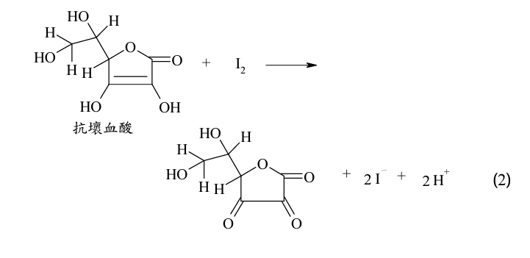
      - Measure 2ml of 1M NaI, 2ml of 1M HCl, 1ml of 2% starch
      - Fill the buret with 5ml 0.025M KIO3, record the original volume in buret Vi
      - Use 0.025M KIO3 to titrate the fresh spinach juice until the solution appears to be blue and does not dyed out, record the volume in buret Vf, repeat for 3 times.
      - Repeat the experiment for boiled spinach,
      - Calculate the content of VC in 100g of spinach.
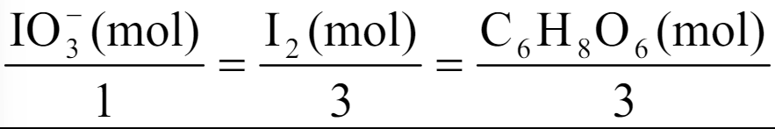
Please discuss the safety precautions.
Source | Safety issue | solution
HCl & H2SO4 | Have Corrosive property, can hurt eyes and skin | Wear safety goggles and operate the solution carefully
Heating (boiling spinach) | Hurt by the heat | Use the test tube clamp to hold the tube.
O2 produced | Flammability, can exploded | Do not do the experiment close to fire.
The deposal of solution | May have H2SO4 and HCl left | Should be dumped into the beaker.

Reference and bibliography:
(Please list at least 3 books or articles you have read.)
https://m.fx361.com/news/2018/0922/20266313.html
https://teaching.ch.ntu.edu.tw/gclab/doc/demonstration/quantitative_analysis_of_vitamin_C.pdf
https://m.antpedia.com/news/2960826.html
Note:
Signature: 姚苏倪 |  | Date: 2024-3-24
(You may edit this form to get more space.)

